Discussion & Meeting on the struggle for
JUSTICE 4 SEAN BELL
And all victims of police killings
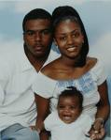
Wed., May 21
7 P.M to 9 P.M.
At: the Yabba Pot
2431 St. Paul St. 21218
(25th & St. Paul Sts.)

- Special Guest speaker:
Tyneisha Bowens – a national
youth and student organizer with FIST
Fight Imperialism Stand Together

- See RECENT video coverage of the protests in New York
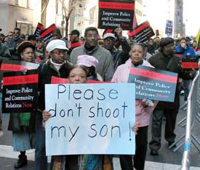Picture of nyc protest from ww newspaper
Sponsored by:
All Peoples Congress;
FIST (Fight Imperialism,
Stand Together); Workers World Party
For info call:
443-220-7919

